BookFlow Lab Guide
Experiment 1: The Intelligent Catalog & API Blueprint
Experiment 2: FastAPI Backend & Security Suite
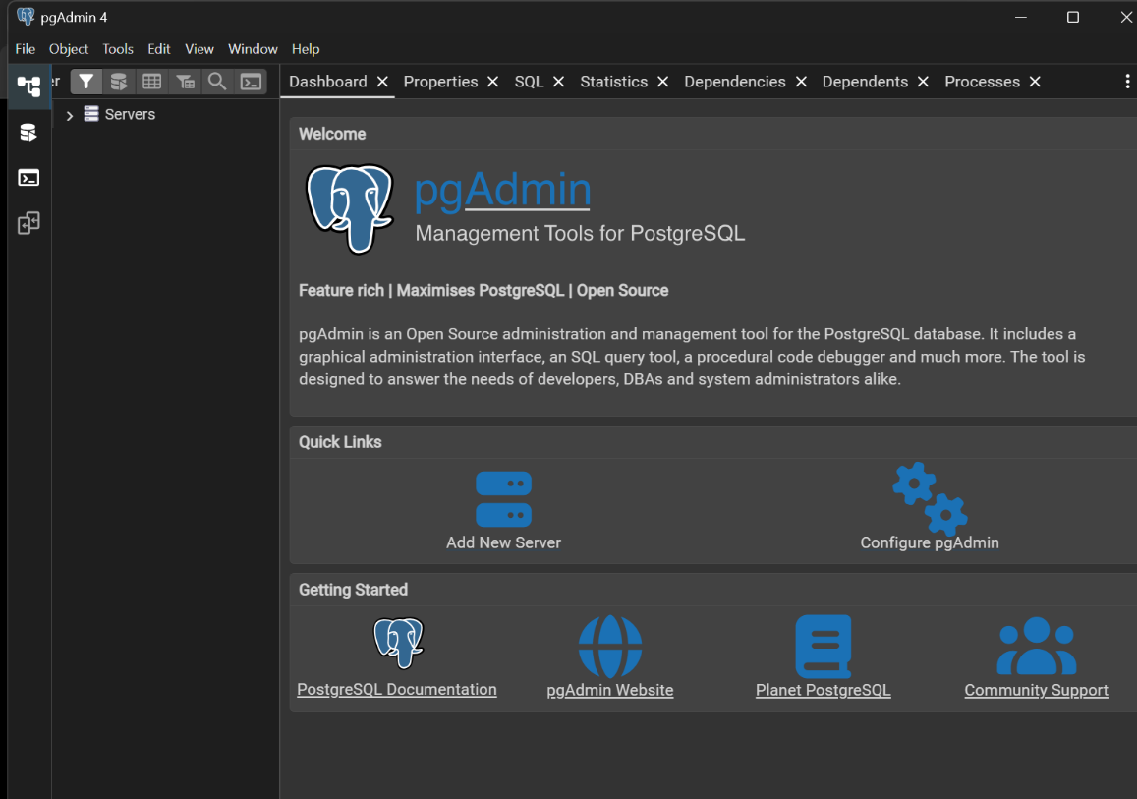
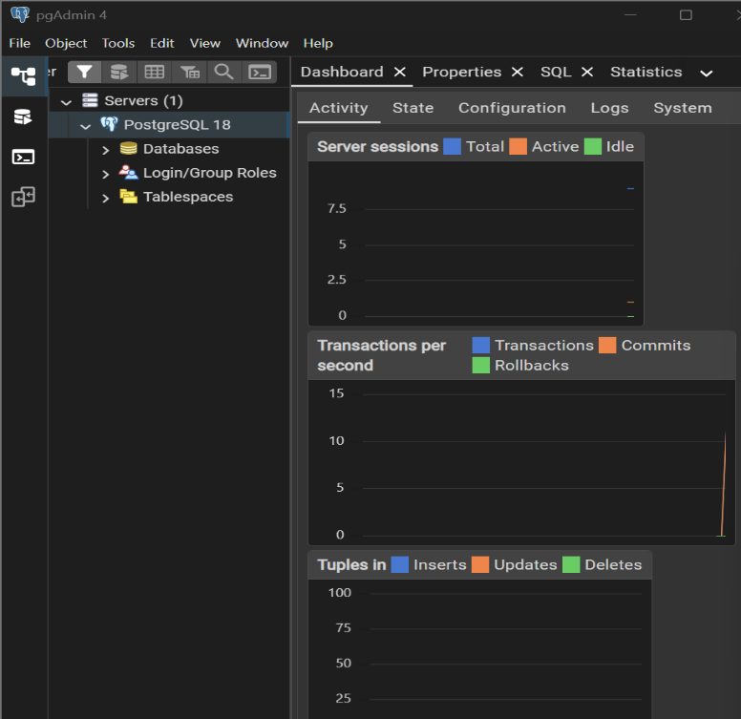
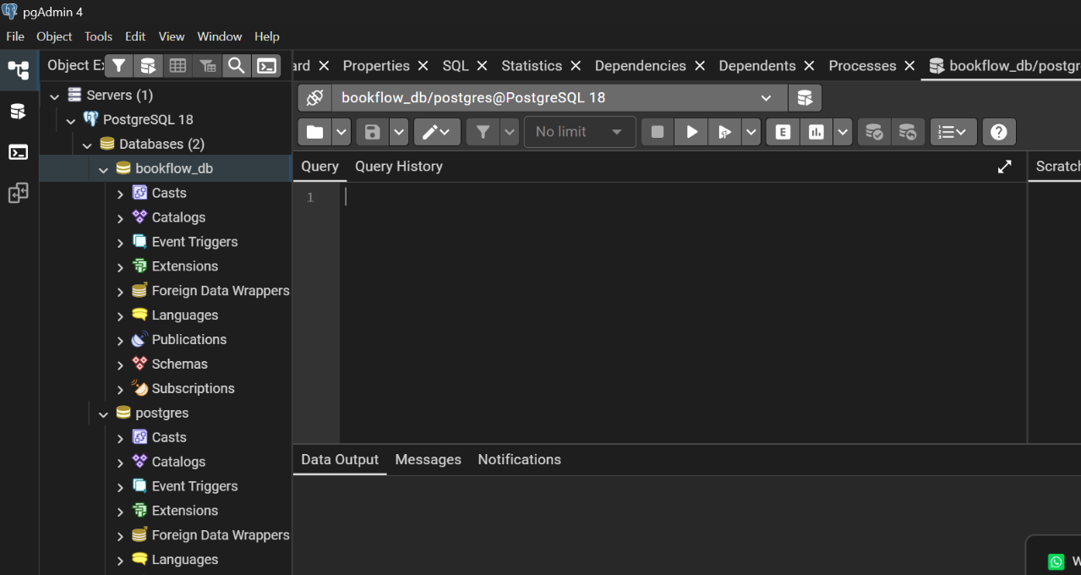\
Create the Books table
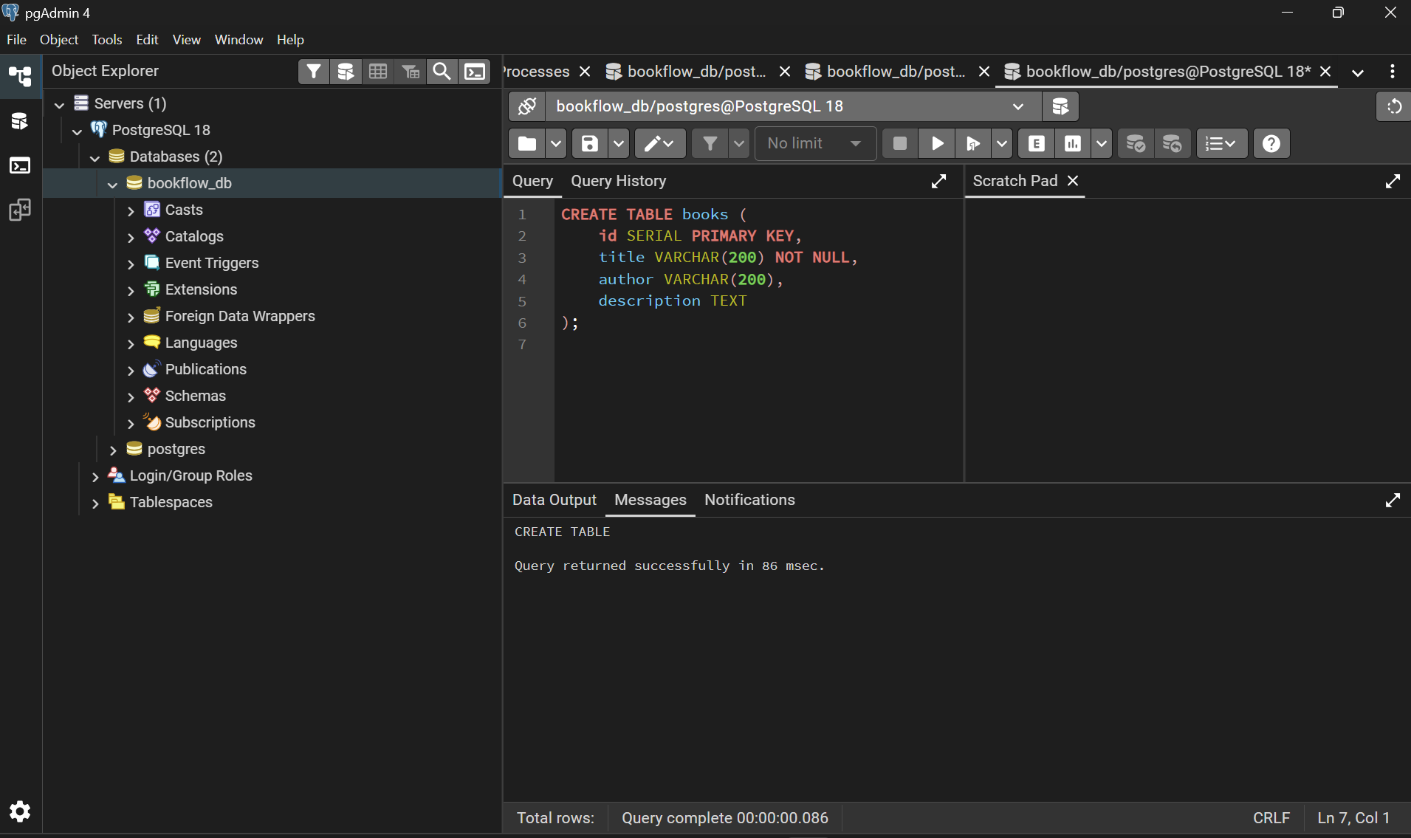
Insert sample books
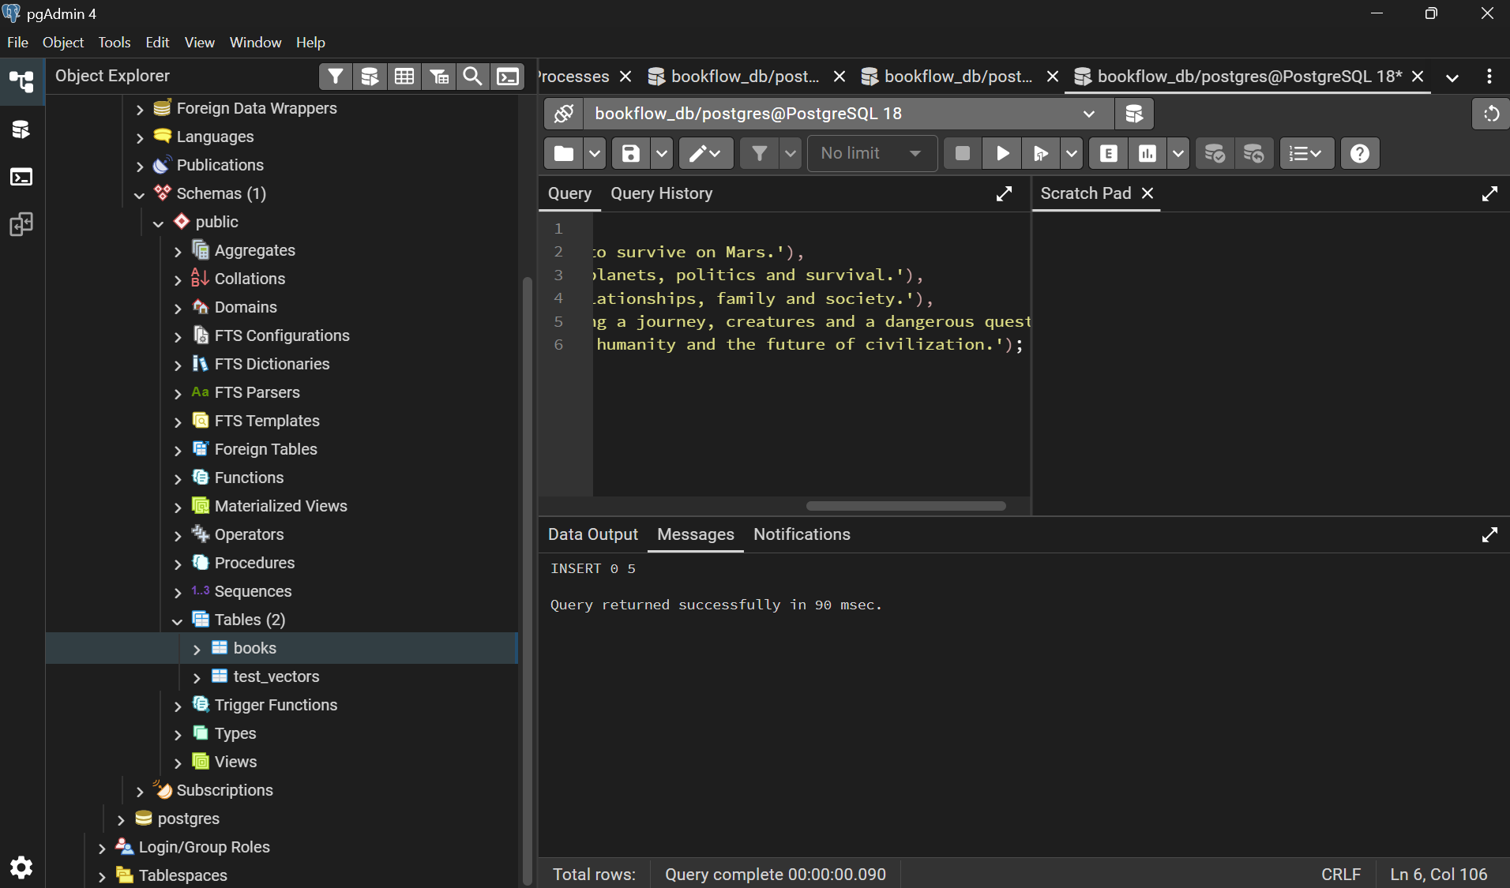

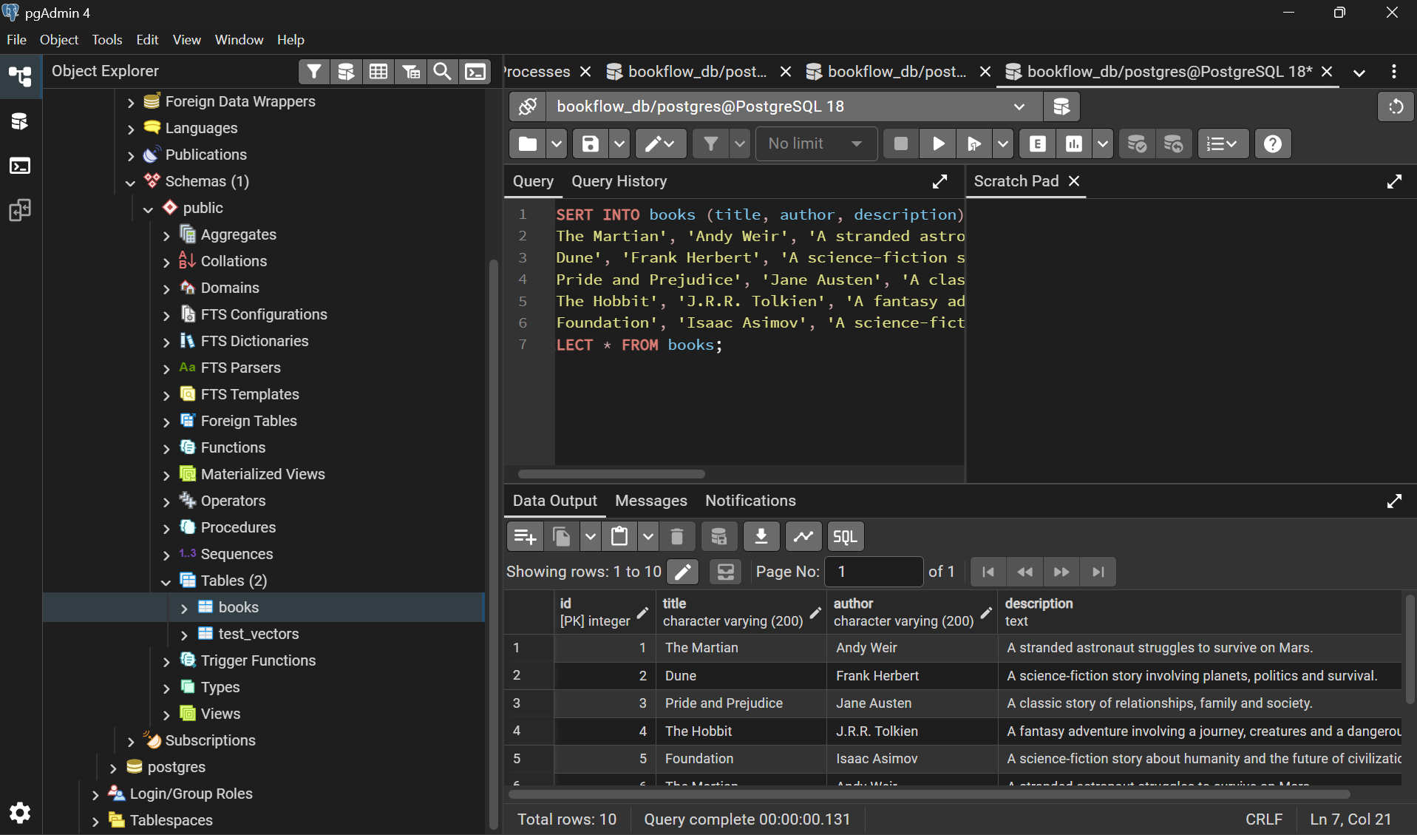
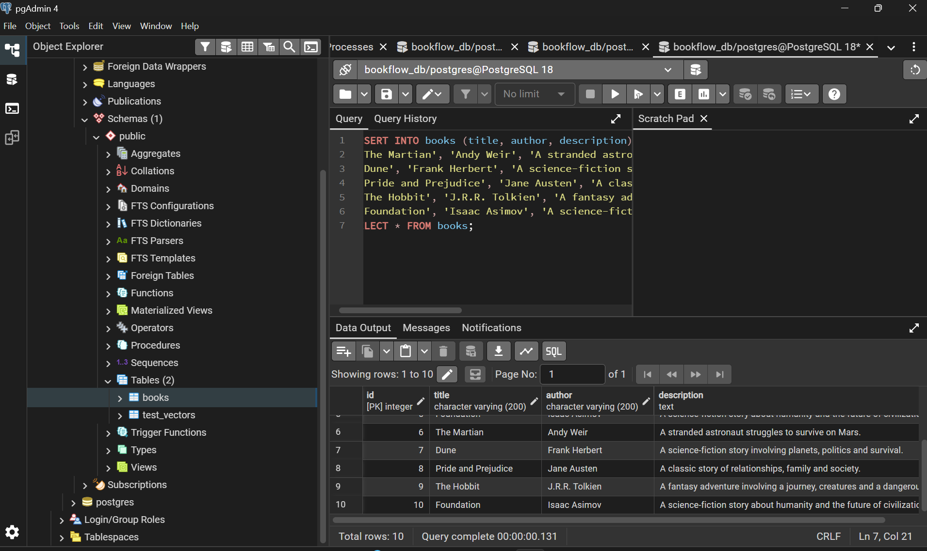
Add the vector column
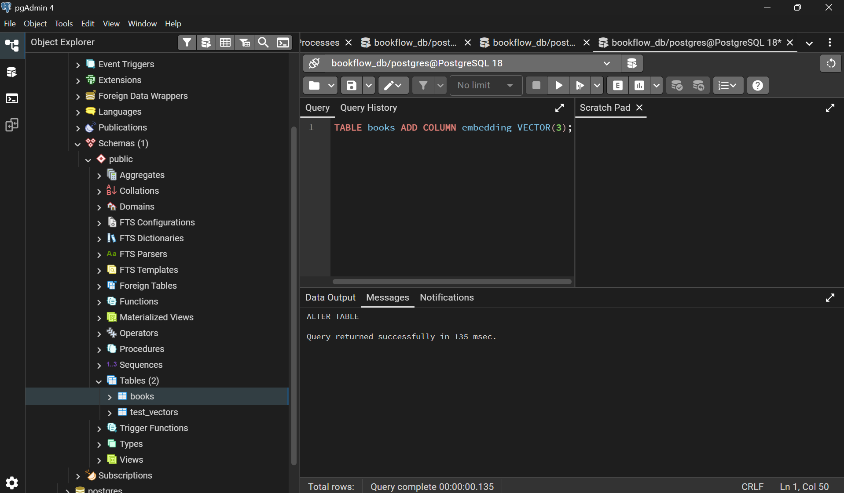

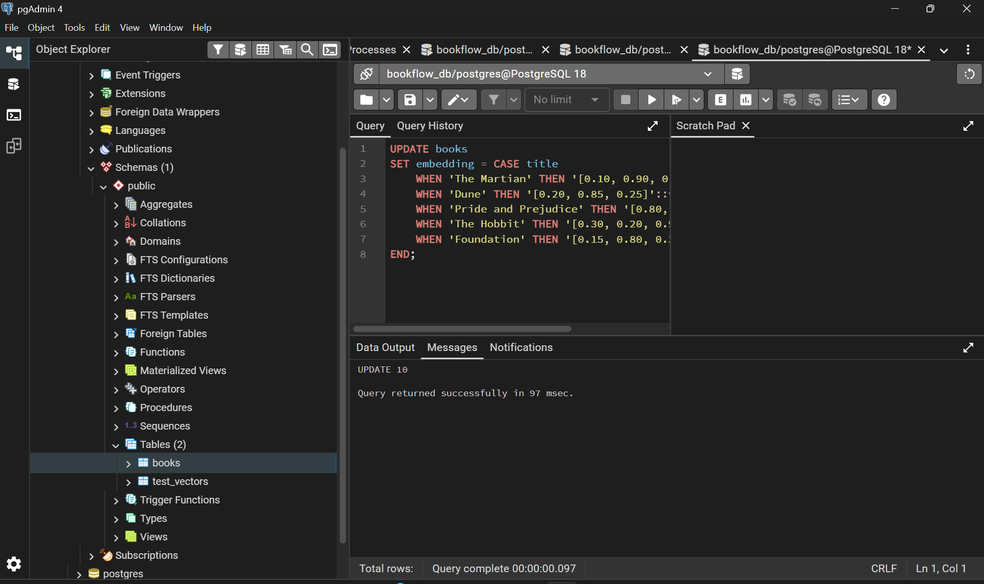
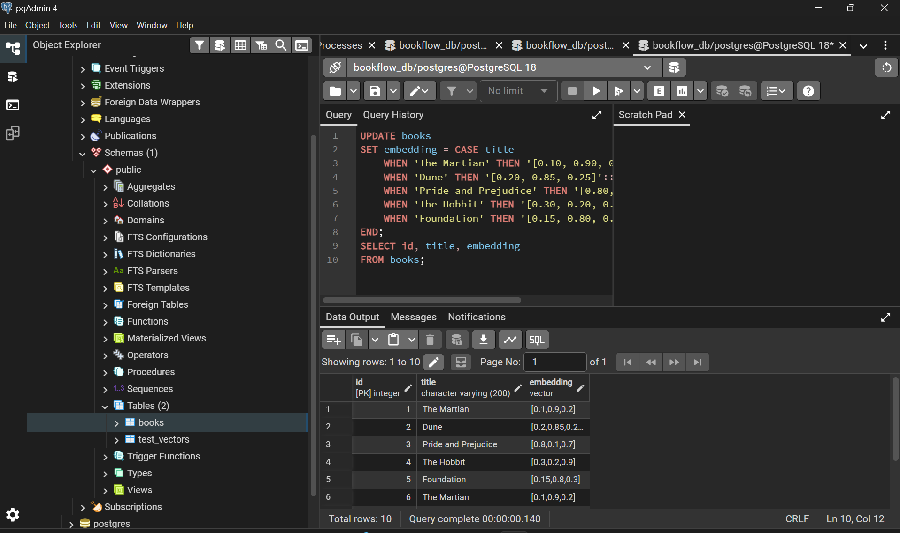

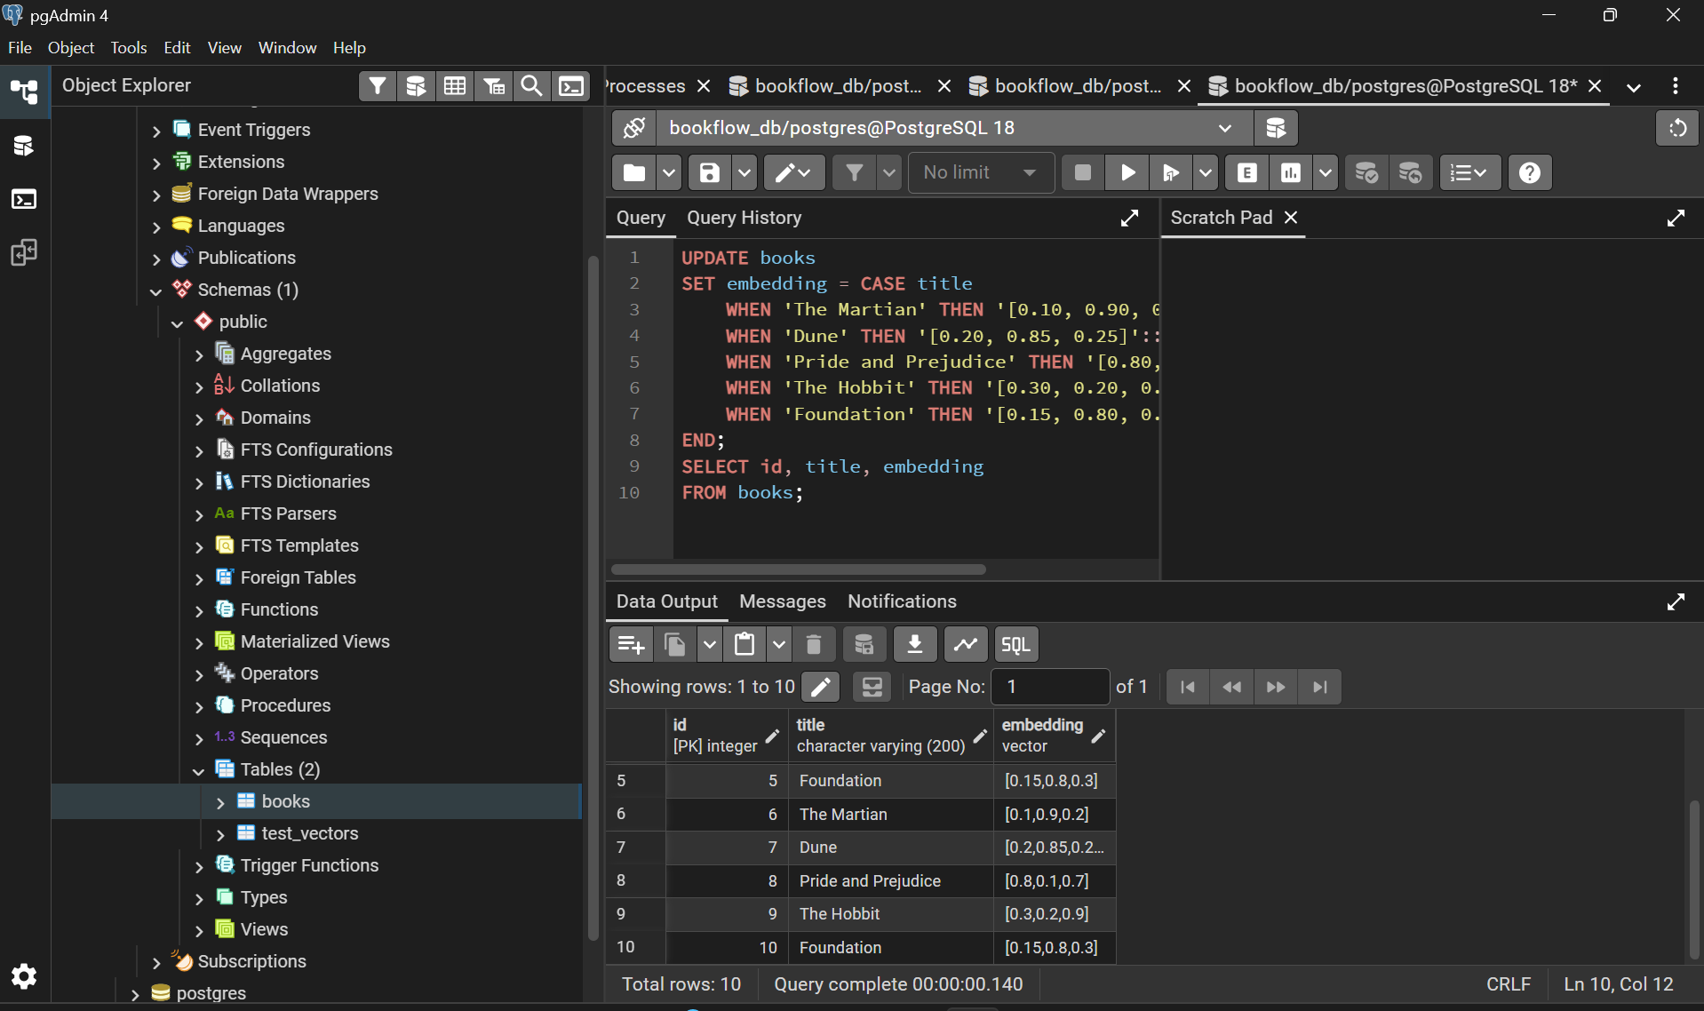
Insert mock embeddings
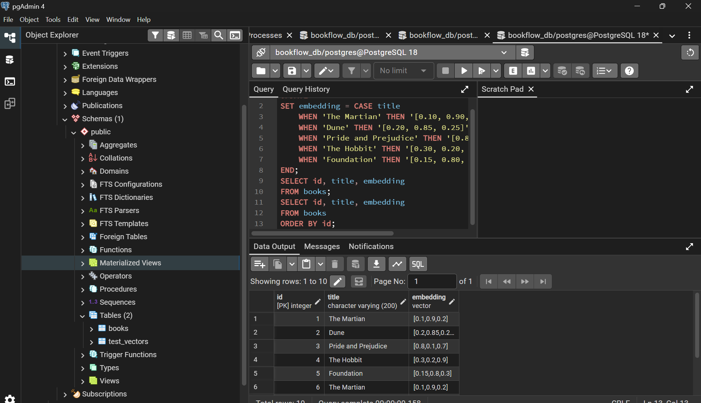
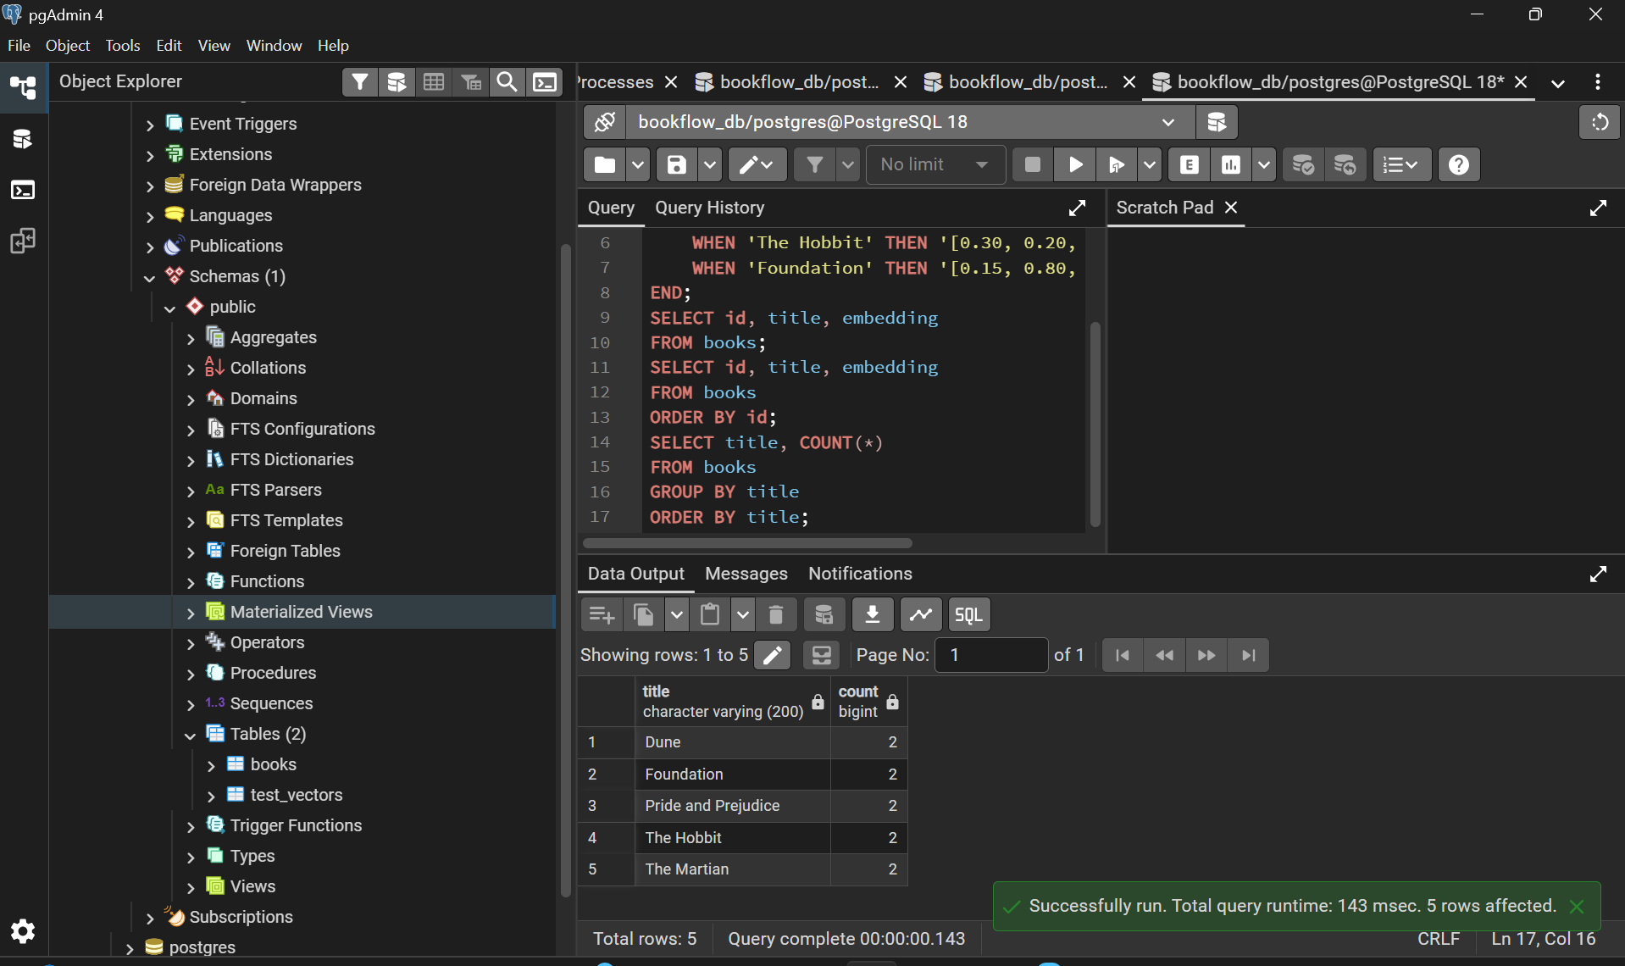
Create a query vector
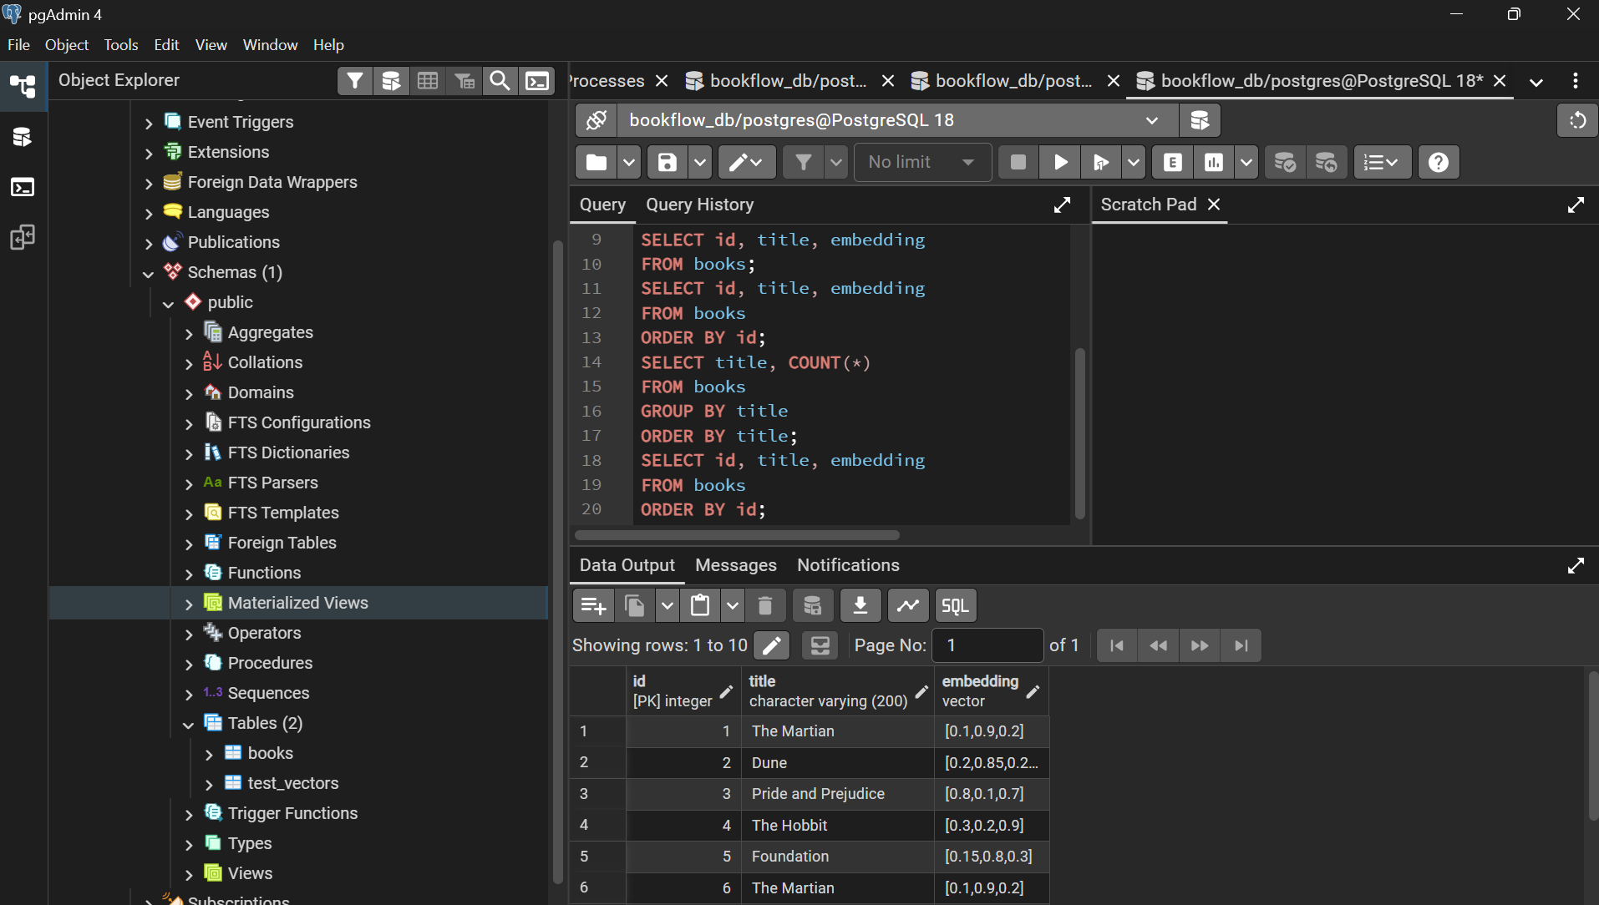
Search using L2 distance
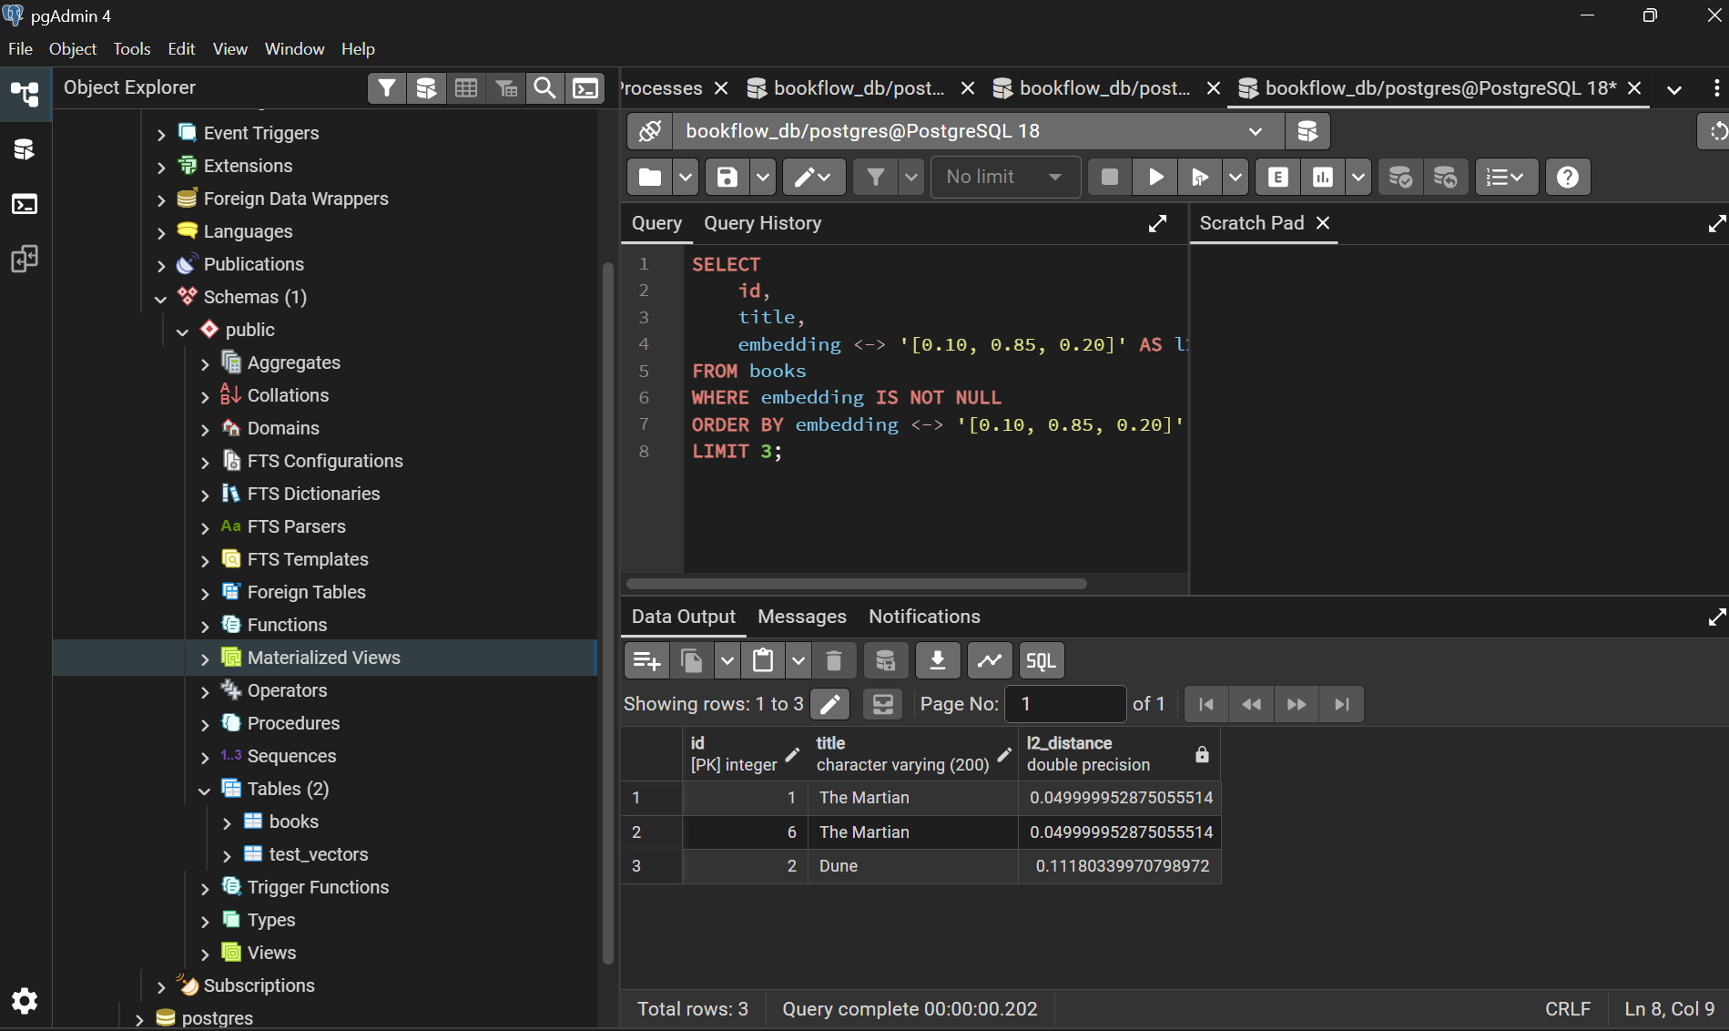
Duplicate value is deleted
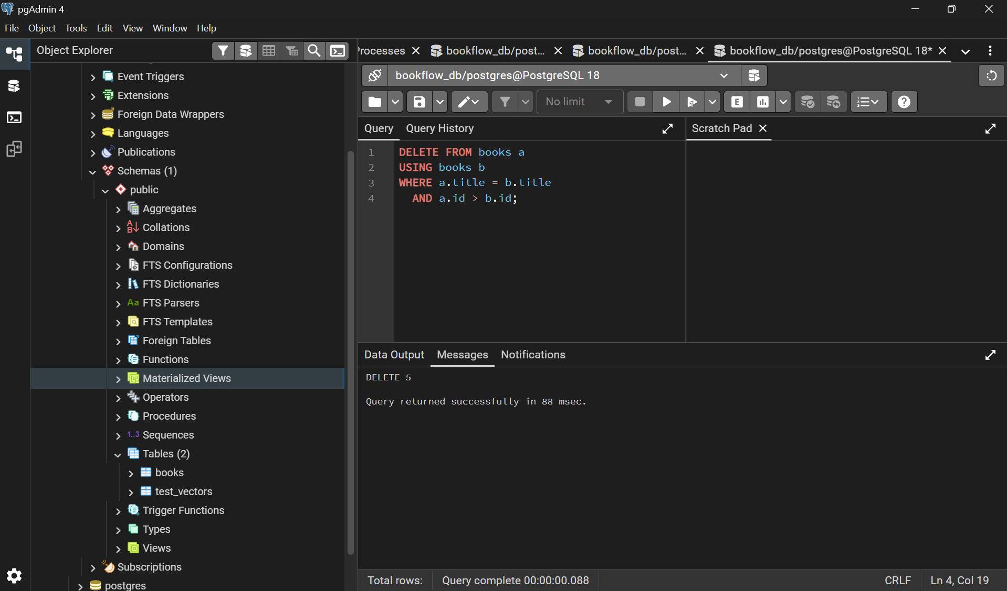

3 different books
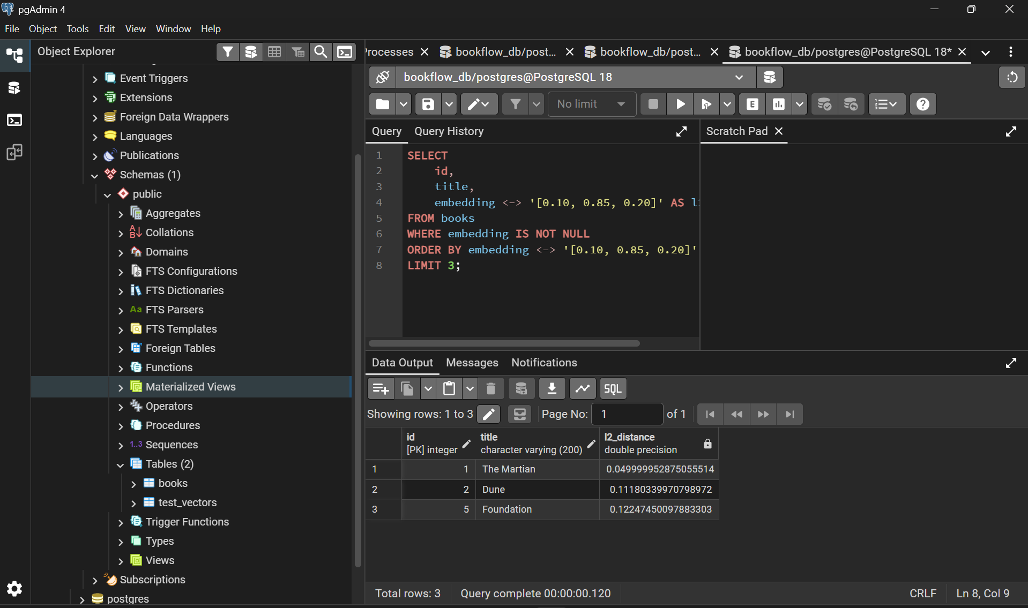
Search using cosine distance
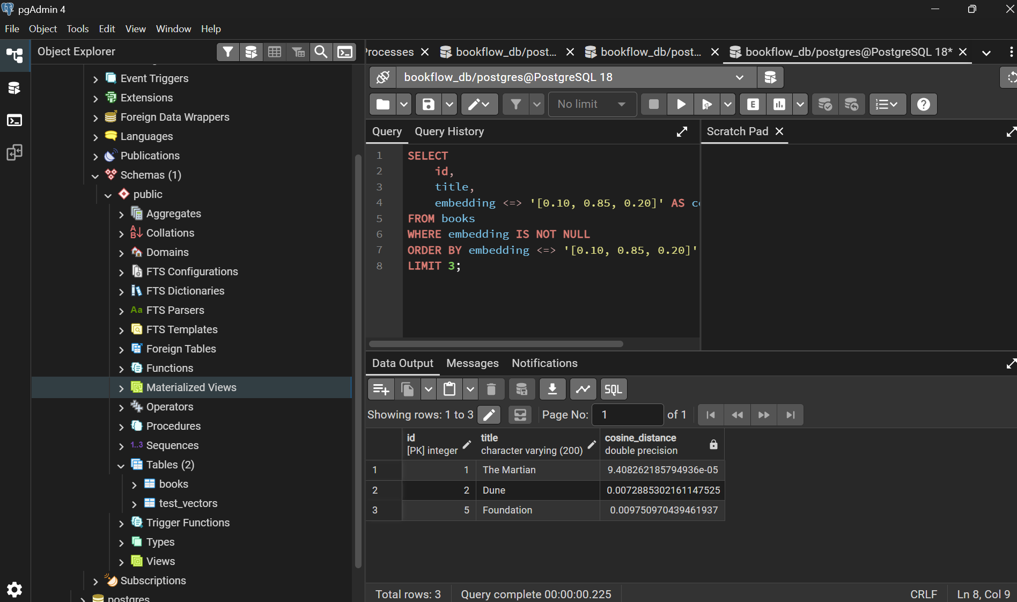
Cosine distance vs cosine similarity
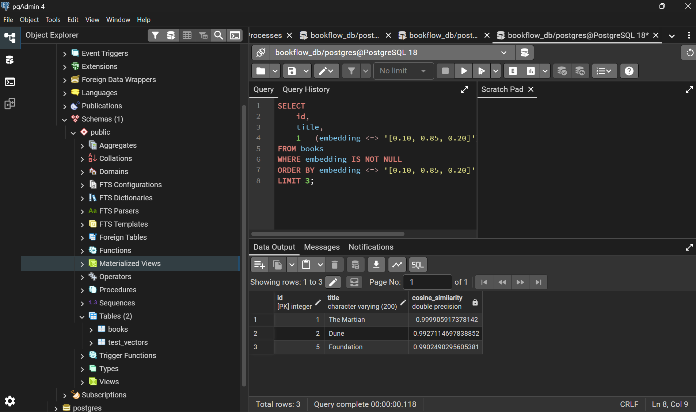
Design the REST API contract (Swagger Editor)
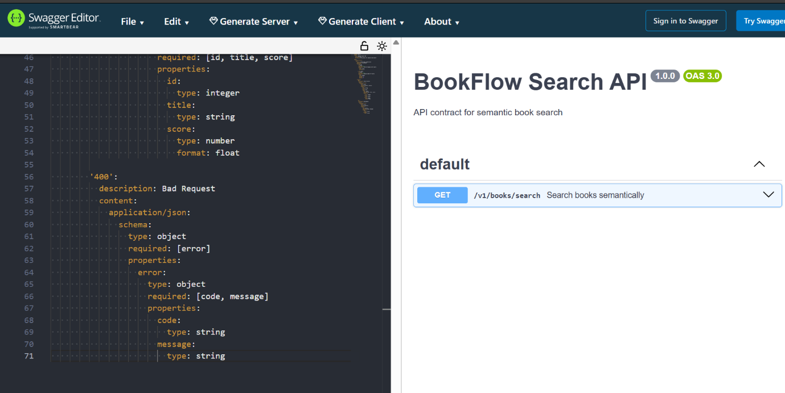

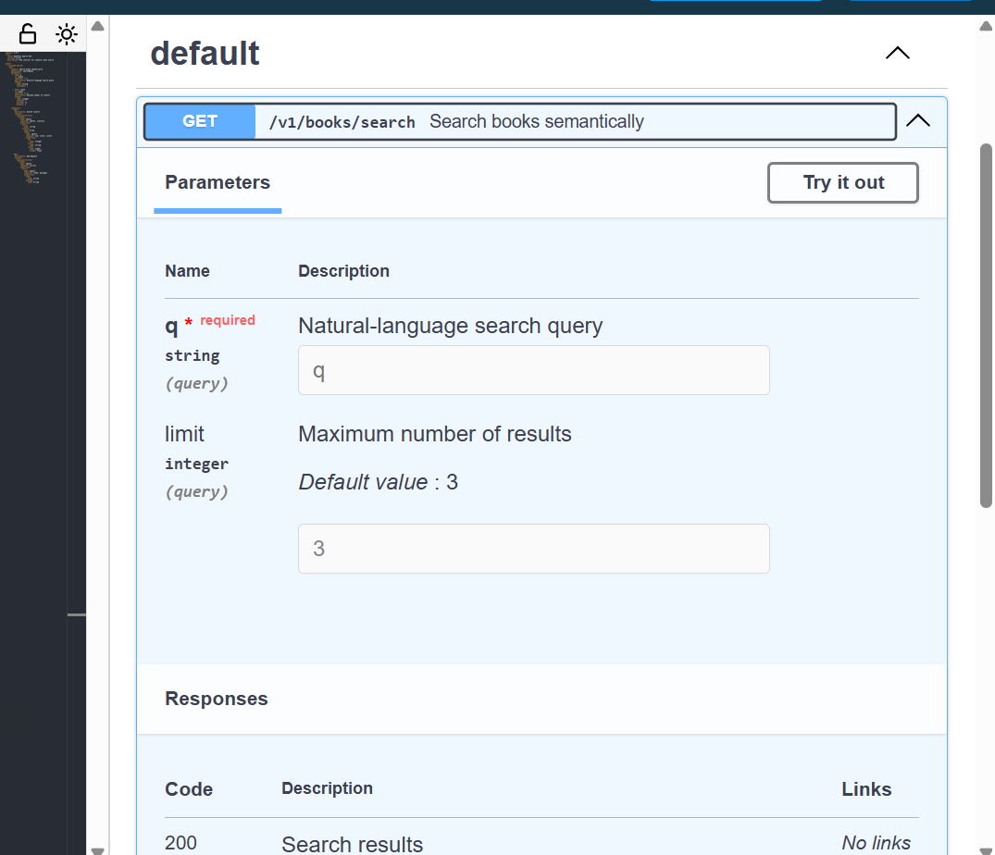
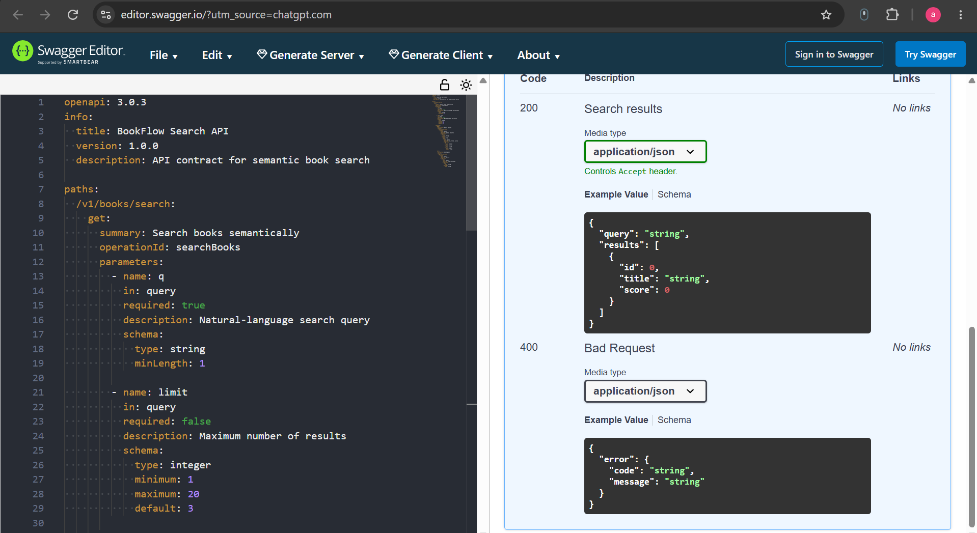
Verifying REST constraints.
Statelessness: The search request carries its required parameters (q and limit) and does not depend on a previous request.
Correct verb: GET is used because the search operation does not change any data.
Conclusion:
Implemented a basic semantic book-search database using PostgreSQL and pgvector. Vector embeddings were stored for books and similarity searches were performed using L2 distance and cosine distance. An OpenAPI specification was also designed for the semantic book-search API, including request parameters, response schemas, validation, and REST principles.

